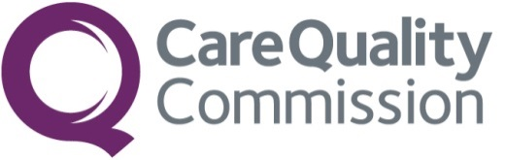
CQC Public Board meeting

Date of meeting: 17/09/2026
Title of paper: Performance, Finance and People Report (Quarter 1)
Purpose of paper: For assurance
Executive sponsor: Chris Usher (Interim Deputy CEO)
Presenter(s) or lead person: Chris Usher (Interim Deputy CEO)

Summary:
This item enables the Board to fulfil its duties in relation to holding the Executive Team to account for performance of the organisation; ensuring robust and effective systems of risk management; and ensuring financial probity and the efficient and effective use of resources, it includes the following:
- Performance monthly balance scorecard covering Quarter 1 (June 2026).
- Finance update covering Quarter 1.
- People and Culture Assurance report covering Quarter 1.
- Board Assurance Framework and organisational risk update covering Quarter 1.

Recommendations: The Board is asked to note the contents.
1. Performance:
1.1 Assessments
- CQC met its commitment of 9,000 assessments in July 2026. By the end of Q1, CQC had completed 8,464 assessments. June saw the highest number of assessments completed, with 802 completed compared to 642 in April and 641 in June.
- At the end of Q1, Adult Social Care had completed 4,905 assessments, Primary and Community Care (Regional Teams) had completed 976 assessments, Primary and Community Care (Oral Health Team) had completed 1,418 assessments, Hospitals (Secondary and Specialist Care) completed 519 assessments, and the Mental Health sector had completed 378 assessments.
- Time to complete assessments in Adult Social Care, Primary and Community Care, Oral Health and Health and Justice sat at 31 days at the end of June against a target of less than 50 days. The time to complete assessments for Mental Health and Hospitals sat at 90 days at the end of June against a target of less than 85 days. Although this is not meeting target, it is a reduction from last quarter, when this sat at 95 days.
1.2 Registration
- The percentage of registration applications completed within 10 weeks sat at 68.4% at the end of June, compared to 67.1% at the end of March. This is not meeting the target of 80%. However, the volume of applications received increased significantly due to improvements in rejecting applications which reached 56.4% of applications in June compared to 38.5% in April, which has increased the number of resubmissions. This follows the introduction of the enhanced validation and document checks for further sectors, as part of CQC’s ongoing quality improvement activity to improve the quality of applications received.
- The volume of applications completed sat at 2,873 in June and the volume of registration applications received reached 7,676 in June.
1.3 Information of Concern (IOC)
- At the end of Q1, 96.6% of P1 cases had a referral completed within 2 working days against a target of 95%. At the end of June, P1 cases having an action completed within 1 day of referral sat at 93.4% against a target of 95%. This is slightly below target and continued efforts are taking place to improve this.
- P2 and P3 performance remains strong , with targets met each month this quarter, with P2s sitting at 97.1% and P3s sitting at 97.4% at the end of June.
1.4 Regulatory Effectiveness (Customer)
- SAR completion at the end of June exceeded 90% (90.1%) set by the Information Commissioner's Office (ICO) as acceptable performance but still below the internal target of 95%. Changes in process for handling requests are bringing improvements in performance.
- 100% of FOIA were answered within 20 working days at the end of June, against a target of 95%.
- MNSI is continuing to achieve and exceed the current KPI’s in relation to investigations and family and Trust engagement. This is currently being achieved with the team experiencing a significantly reduced workforce across a number of areas. The team are looking closely at where this will impact our performance in the future and how this can be mitigated.
- NCSC call lines continue to perform well. All four call lines met in-month, 6-month rolling and year-to-date targets.
1.5 Business Processes
- All 153 local authorities were assessed within the planned two-year timescale.
- Baselining of LA assessments is complete, with all on-site assessments of 153 local authorities conducted and almost all reports published.
- Following the relaunch of Give Feedback on Care (GFOC), customer satisfaction scores are around 10% lower than historically reported due to the introduction of a wider response scale. While the inclusion of GFOC has increased the combined website and GFOC satisfaction measure, performance remains below pre-relaunch levels. Trends will continue to be monitored.
- The number of health and safety incidents, accidents and near misses increased in Q1, with 48 incidents being reported in June. CQC reported 264 incidents in the last 6 month period, compared with 298 being reported in the entire year 25/26. This is being monitored closely.
- Multi-Agency Operations teams delivered 18 IR(ME)R regulatory activities, 29 Children’s Services Assessments, 19 Health and Justice assessments, 10 Safehouse assessments, 13 Defence Medical Services assessments, and 353 Medicines Optimisation regulatory activities in Q1.
- At the end of June 1,740 second opinions were awaiting an appointment, this has reduced from 1,874 at the end of March. Monthly SOAD Day clinics have been set up and are now in place at Leeds and Yorkshire Partnership NHS Foundation Trust. 100% of Section 61 reports were scrutinised within 14 days.

2. Finance
- At the end of June 2026 a £1.2m surplus is reported due to phasing of expenditure in year, however a £5.9m deficit is forecast by the end of the financial year across all revenue funding streams.
- This is predominantly driven by spend on our Rebuilding work which remains unfunded until DHSC have gained the necessary assurances via their Investment Committee; and a time lag in further Grant-in-Aid allocations for LAA, ICETR and MNSI work from DHSC, with confirmation of allocations to be made in-year as part of the Consolidation process. Additionally, depreciation forecasts now reflect the final impairment to Regulatory Platform and estimates for the potential impact of asset replacement and changes to asset life.
- These pressures are partially offset by a £1.6m favourable variance on income due to register and data changes.
- Accounting for emerging risks to our revenue financial position, the 2026/27 deficit reported could range from £4.3m to £9.6m accounting for ‘downside’ risks of Rebuilding activities, inspectorate activity volumes, and a pay award above the 3% budgeted; and ‘upside’ risks relating to inspectorate vacancies and our ability to stand up and utilise the level of bank and overtime forecast.
- There is still work to be done on the realism and accuracy of revenue forecasts and we know we face a financial challenge in future financial years This will require additional revenue spend in 2026/27 (excluded from the position reported) to provide a more financially sustainable position going forward, mitigated by cost improvement changes.
- Whilst no capital expenditure has been incurred at this early point in the financial year, our capital budget has increased to £13.0m in 2026/27 and is expected to spend in full accounting for our Rebuilding activity.

3. People and Culture (As of June 2026)

3.1 Workforce Composition
- Vacancy rates have decreased to an organisational average of 7.4%, although still exceed our 5% target. We will continue to monitor through our regular reporting. Digital and Data continues to have the highest Executive Directorate vacancy rate with 13.0% although this has decreased from April 2026 (18.2%).
- We currently have 94.9% permanent staff across the organisation, with an average fixed term contract length of 1.9 years. Work has been ongoing with a working group to review our use of fixed term contracts. This review has focused on reducing reliance on repeated contract extensions, improving the experience of colleagues, and ensuring a consistent an equitable approach across the organisation in the longer-term.
- Use of Contingent Labour continues to be an area of focus with reporting provided bi-monthly to the People Leadership and Culture Committee. The latest report summarised that there has been a large decrease in the use of Contingent Labour across the organisation since January 2026 and our Business Partners continue to work with business areas to further reduce this.

3.2 Turnover
- Our organisational 12-month turnover rate is 7.6% which is within our KPI of 10%. Whilst this is within target, we know that in some parts of the business our turnover is greater, for example Policy and Strategy teams have a combined turnover of 16.3% over a 12-month period. Corporate Services, which was over the KPI in April 2026 has now dropped to 9.1% (within KPI).
- People Survey results show improved retention sentiment across CQC with 66% of colleagues indicating they would like to work at CQC in 12 months time. The highest scoring directorates were Digital and Data (73%) and Corporate Services (72%). Engagement, Policy and Strategy recorded the lowest positive response (49%), consistent with higher turnover. Hospitals (58%) and Primary Care and Community Services (60%) were also below the overall CQC score.
- We expect our turnover to vary as colleagues in enabling functions experience people change, supporting their wellbeing is paramount to any change undertaken.

3.3 Recruitment
- Recruitment has maintained 100% fulfilment rate (compared to 100% in April 2026) while the vacancy rate has reduced to 7.4%. This demonstrates increased effectiveness within our recruitment processes, whilst helping to alleviate workforce pressures and supporting reducing staff absence.
- Our successful candidate attraction is almost equally split with 49.2% of successful candidates being recruited externally compared to 50.8% internally, reflecting our ability to attract new talent while supporting career development opportunities for existing staff.
- This is reinforced by our 2026 survey data on experiences of equal opportunities for career progression or promotion, which has increased by 9% since the 2025 Equity, Diversity and Inclusion Pulse Survey.

3.4 Equalities data in recruitment and representation
Recruitment and workforce data continue to demonstrate progress towards CQC’s diversity objectives, with representation of colleagues from ethnic minority backgrounds (19.4%) and disabled colleagues (17.1%) broadly aligned to the ONS working population and showing continued improvement since April 2026. Recruitment outcomes indicate no adverse impacts for disabled candidates, although a high level of non-disclosure of disability status among successful candidates may affect the completeness of reporting.
Board may wish to note that:
- 24.7% of successful candidates were from an ethnic minority background and 14.9% identified as disabled.
- Workforce representation has increased since April 2026, with ethnic minority representation rising from 19.0% to 19.4% and disability representation from 16.6% to 17.1%.
- Representation varies across directorates, with the highest proportion of ethnic minority colleagues in Digital and Data (29.2%) and the lowest in Adult Social Care (14.6%).
- Disability representation ranges from 13.8% in Hospitals to 24.9% in Mental Health.
- LGBT+ representation remains consistent throughout the recruitment process, with 9.3% of applicants and 9.8% of successful candidates identifying as LGBT+.
- New People Survey data on gender identity has been included to strengthen workforce diversity monitoring, with 65.8% of respondents identifying as female, 23.1% as male, 0.7% as another gender identity and 10.4% preferring not to say. 0.6% of respondents reported that their gender identity is different from their sex registered at birth.

3.5 Absence
- Our organisational sickness rate remains consistently below the KPI of 5.0% at 4.2%. In the previous quarter, we highlighted that the combined Operations and Inspectorates were the highest with a sickness rate of 5.5%, this has now dropped to within KPI at 4.5% for the 12-months prior to 30th June 2026 which indicates a positive change.
- When benchmarking against other organisations using their 2024/25 annual reports, NHS England recorded a sickness absence rate of 3.05%. The Care Inspectorate recorded a sickness absence rate of 5.3%. This puts CQC in between the two organisations.
3.6 Required Learning (Quarter 1)
- Quarter one is now complete, and as of 26th August 2026, the overall completion rates for
mandatory training this quarter are below:
  - Bullying and Harassment – 85.4%
  - Fraud Prevention – 85.3%

- We have redesigned our Learning Management System to make it clearer for individuals to understand what programmes are required and when, this information is also available to all line managers through our regular People Hub reporting so the information can be monitored and remedial action taken where necessary.
- For Bullying and Harassment, the highest Executive Directorate completion rate is Digital and Data (92.9%) and the lowest completion is within Engagement, Policy & Strategy (68.6%). For Fraud Prevention, the highest completion rate is Corporate Services (94.6%), and the lowest completion is Engagement Policy and Strategy (65.3%).
4. Risk and Board Assurance Framework
- During Quarter 1, the Risk Committee continued its oversight of the Board Assurance Framework (BAF) and organisational risk profile. The quarter saw further progress in aligning principal and operational risks, supporting greater consistency in risk reporting and management across the organisation. The Committee reviewed key risk themes relating to organisational performance, workforce capacity and capability, strategic transformation, governance effectiveness, and digital and data dependencies.
- The BAF summary was also refreshed to provide greater focus on those principal risks operating furthest outside the organisation's risk appetite, with these risks presented first to support Board visibility and discussion. A summary of the BAF at close of Q1 has been included within this report, providing an overview of principal risks, risk appetite positions, score movements, and assurance ratings.
- The quarter also saw an improvement in assurance coverage, with the Cyber Security & Resilience principal risk moving from limited to moderate assurance. This reflected strengthened assurance over the effectiveness of key controls and mitigation activities and represented positive progress in the organisation's management of a significant strategic risk.
- This activity contributed to the ongoing development of the organisation's risk management and assurance arrangements. The Board Assurance Framework was also subject to detailed quarterly review through the Audit and Risk Assurance Committee, providing additional assurance regarding the effectiveness of the organisation's risk management and control arrangements. A more detailed review of the Board Assurance Framework is scheduled for consideration at the Board's next public meeting in November.
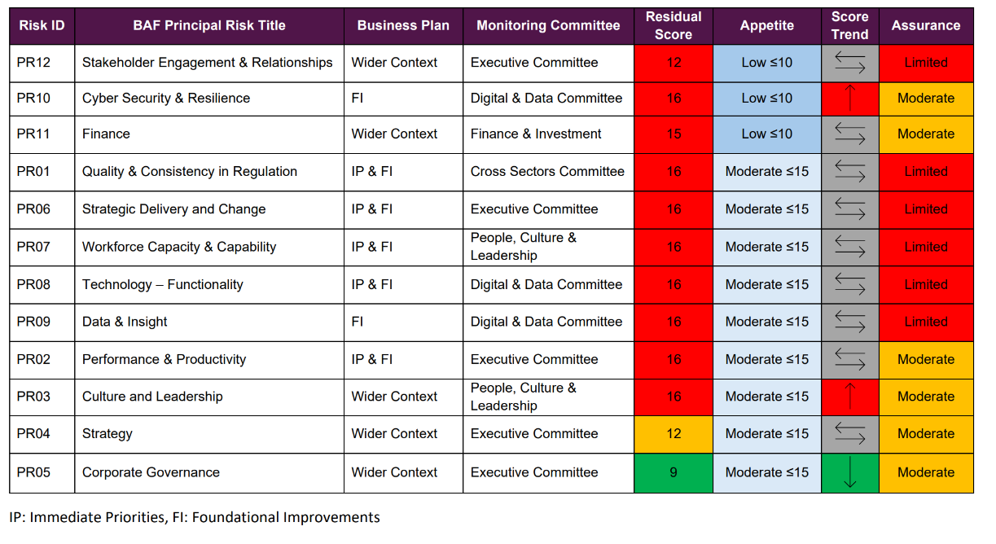
Contributions:
The performance team lead on the information provided in the Performance section of this paper, with support from colleagues identified as business leads for the metrics outlined. The Finance team have led on the Finance section of this paper. The People and Culture section was populated by the People Directorate People Analytics Team, Resourcing Team and Business Partnering.

Outcomes and next steps:
CQC Board are asked to discuss the performance, finance and people updates detailed in this paper. We will continue to work with the business to monitor relevant data and metrics.

Appendices:
- Annex 1: The CQC Balanced Scorecard and People Data pack for July to June 2025/26

